**Computer Programming 1  
Essential Standard 4.00 Understand Variables and Naming Conventions  
Challenge Exercise**

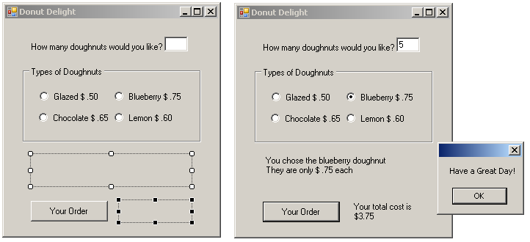

Create a new project called donutDelight.

* Add the controls shown on the design image above.
* Declare variables for the price of a doughnut and for the quantity.
  + The price of the doughnut will be set in each RadioButton CheckChanged event, so declare the price variable globally. This way you can use the price variable in the button click.
* Create RadioButton CheckChanged events
  + Display an appropriate message and the cost of that type of doughnut on separate lines.
  + Set the price variable equal to the appropriate price.
* In the button click
  + Display the total cost in the second label
    - Your cost should be formatted.
  + Display a MessageBox with the shown message.